Lab 3: Part 1

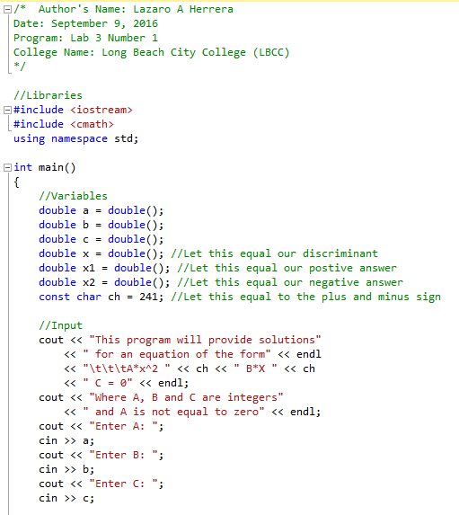

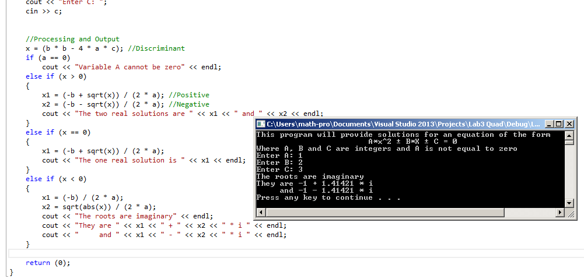

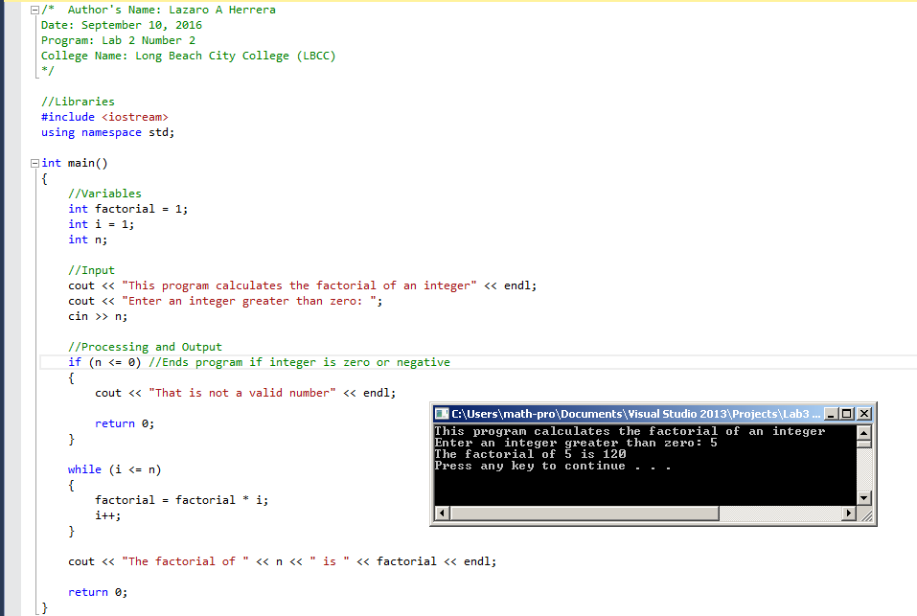

Lab 3: Part 2

Four errors

1. The int “total” was never initialized so you cannot add anything to it.
2. After you took the input value for x2 it was never used again in the code.
3. The double “average” does not give out the correct average based on the logic in code.
4. The “endl” should not be in quotation marks.

Lab 3: Part 3

